**Q1.**This graph shows the distance Alfie and Chen walked in an afternoon. They started at 1:45pm and had two breaks.

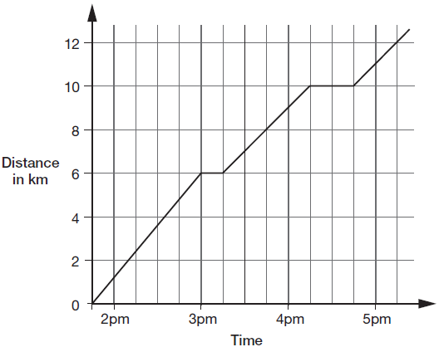

1. What was the time after walking 6km?
2. What was the time after walking 10km?
3. What was the time after walking 9km?
4. What was the time after walking 5 km?

**Q2.**          This graph shows how the temperature changed in Liam’s room one afternoon.

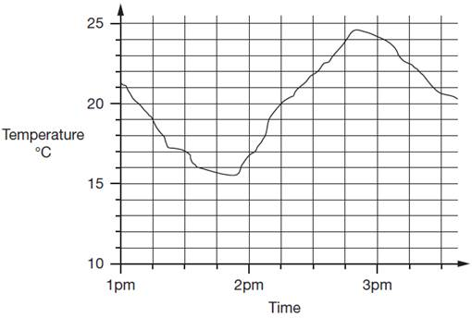

1. Estimate the time when the temperature was at its highest
2. Estimate the time when the temperature was at its lowest
3. What 2 times was the temperature at 17 degrees?
4. What 2 times was the temperature at 22 degrees?

Q3. This graph shows the temperature in a greenhouse.

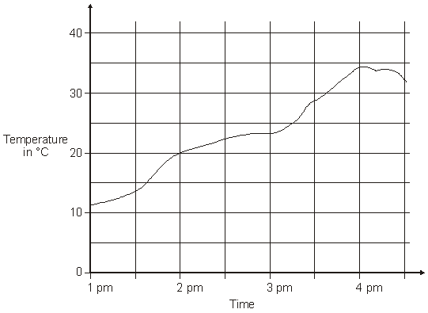

1. Estimate the time the temperature was 20 degrees.
2. What time was the temperature at 25 degrees?
3. What time was the temperature at 27 degrees?
4. What time was the temperature at its highest?

Mastery Challenge 

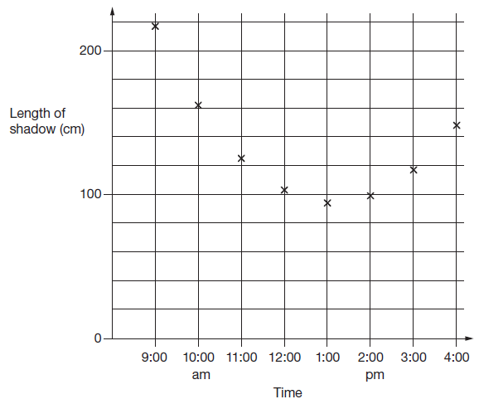

1) How long did it take for the shadow to shorten from 200cm to 1m? How did you calculate?

2) The answer is 11:13. What was the question?

SECTION 1

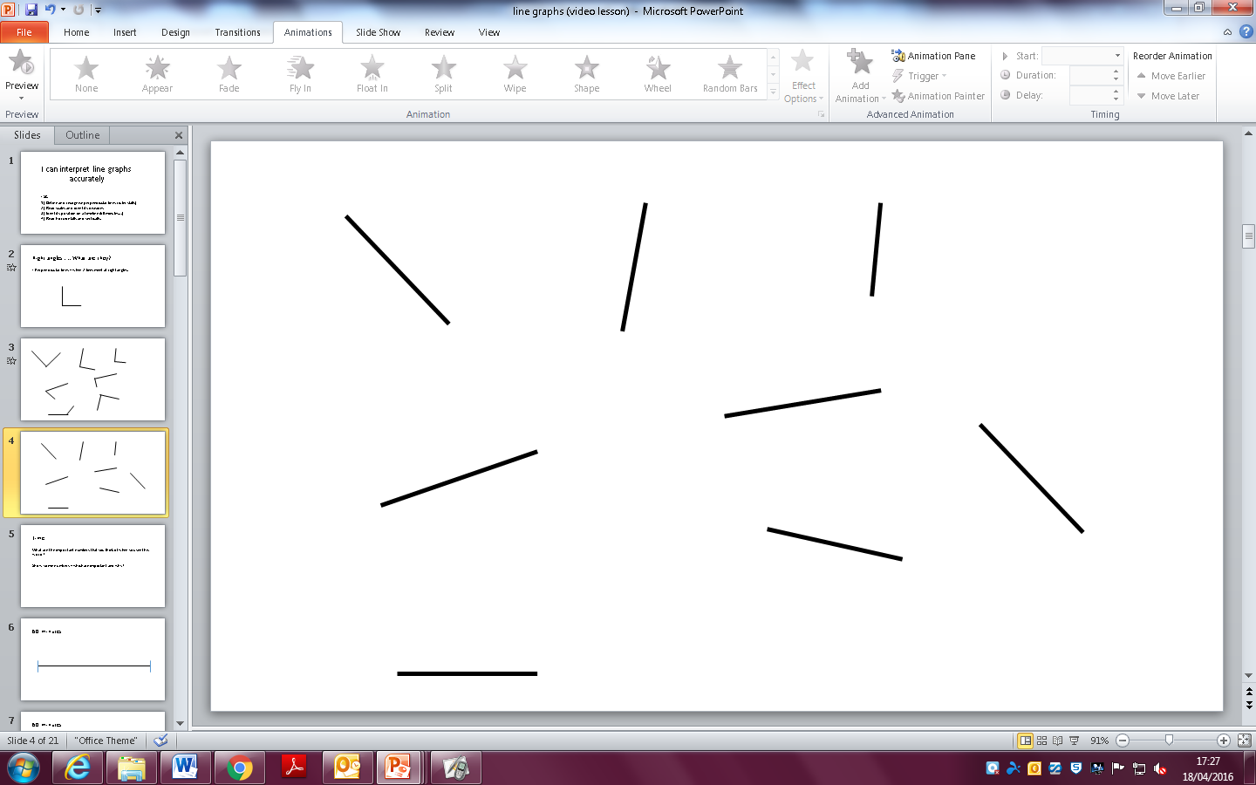

SECTION 2

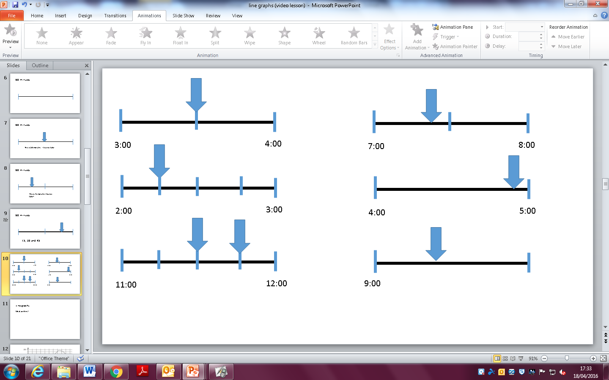

What possible answers could there be for this final question?

What can you do to make the answers different?