Finding the difference 11/05/16
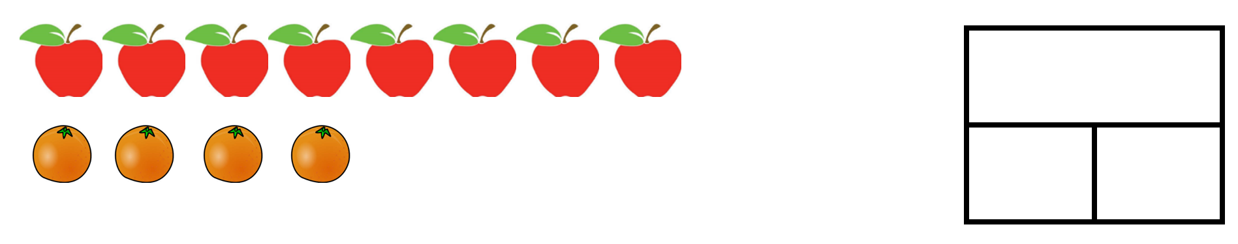
The difference is _____________

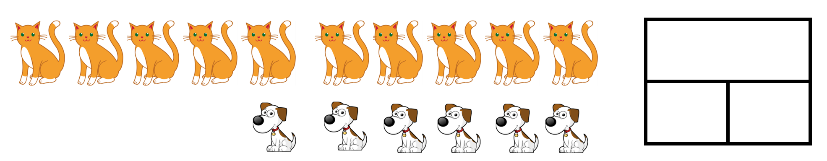
The difference is _____________
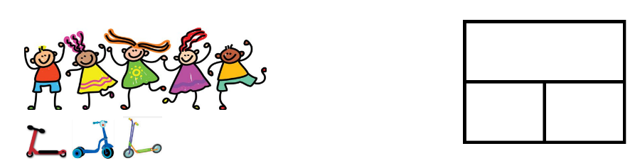
The difference is _____________

The difference is _____________
The difference is _____________

Year 1 and Year 2 have earned some house points.
There is a difference of 2 between their scores.
How many house points might Year 1 and Year 2 have?
Find many different answers!

