Mastery Professional Development

Multiplication and Division

2.17 Structures: using measures and
comparison to understand scaling

Teacher guide | Year 4

Teaching point 1:
A longer length can be described in terms of a shorter length using the language of ‘times’; the longer length can be calculated, if the shorter length is known, using multiplication.

Teaching point 2:
A shorter length can be described in terms of a longer length using the language of fractions; the shorter length can be calculated, if the longer length is known, using division.

Teaching point 3:
Other measures can be compared using the language of ‘times’ and fractions, and calculated using multiplication or division.

Overview of learning
In this segment children will:
- be introduced to the idea of multiplication by a whole number as scaling, either to compare a larger measure to a smaller measure, or to consider an increase in value of one measure
- be introduced to the idea of multiplication by a unit fraction as scaling, either to compare a smaller measure to a larger measure, or to consider a decrease in value of one measure
- use their understanding that multiplying by a unit fraction is equivalent to dividing by the denominator to link scaling to division.
The structure of multiplication and division as scaling has already been used in the context of doubling and halving in segment 2.5 Commutativity (part 2), doubling and halving and 2.6 Structures: quotitive and partitive division (Teaching point 4), and in the context of multiplying/dividing by 10 and 100 in segment 2.13 Calculation: multiplying and dividing by 10 or 100. In both cases, the scaling was applied to quantities of countable objects, for example, half/double the number of birds or ten times as many pencils. In this segment, scaling is explored in the context of measures, beginning with length. This segment also uses both multiplication by a unit fraction (beyond ‘half’) and dividing by the corresponding denominator to find a decreased length (or other measure).
Scaling is distinct from the grouping structure of multiplication (which has been connected to repeated addition) and from the quotitive and partitive structures of division (which have been connected to repeated subtraction). Multiplication as scaling considers an overall increase (when multiplying by a whole number) or decrease (when multiplying by a proper fraction) in value. Scaling can represent multiplicative contexts that repeated addition cannot, such as decreasing the size of an object or situations that do not represent multiple copies; for example, when a sunflower grows to ten times its original height, the outcome is not ten sunflowers but one taller sunflower. Before working on this segment, it is important for children to be fluent with their times table facts (and appropriate mental/written methods for factors larger than 12); if children are still reliant on recitation up to the desired multiple, or on repeated addition, they will be less focused on the scaling structure.
This segment has strong links to Spine 3 Fractions, segment 3.6, which covers the equivalence of multiplying by a unit fraction and dividing by the denominator. There is some overlap of concepts between these two segments, and teachers may wish to integrate teaching from the two segments.
This segment focuses on the exploration of structures; teachers should note that the term ‘scaling’ is not introduced to children until segment 2.27 Scale factors, ratio and proportional reasoning.
Note: in representations, measurements have been drawn proportionally correct but scaled to fit the available space.

An explanation of the structure of these materials, with guidance on how teachers can use them, is contained in this NCETM podcast: www.ncetm.org.uk/primarympdpodcast. The main message in the podcast is that the materials are principally for professional development purposes. They demonstrate how understanding of concepts can be built through small coherent steps and the application of mathematical representations. Unlike a textbook scheme they are not designed to be directly lifted and used as teaching materials. The materials can support teachers to develop their subject and pedagogical knowledge and so help to improve mathematics teaching in combination with other high-quality resources, such as textbooks.

Teaching point 1:
A longer length can be described in terms of a shorter length using the language of ‘times’; the longer length can be calculated, if the shorter length is known, using multiplication.

Steps in learning
 | Guidance | Representations
 | In Spine 1: Number, Addition and Subtraction, segment 1.1, children learnt to use comparative adjectives (longer and shorter, heavier and lighter etc.) to compare measures. By this point (year 4) children should be confident comparing both ordinal and cardinal quantities, and describing them with respect to one another. In this teaching point and the next, working with the example of length, language will be developed to support the connection between comparison and multiplicative reasoning; one length will be scaled to produce another length.  Throughout this teaching point, work practically, providing children with ribbon or strips of paper cut to the appropriate lengths; use lengths equal to a whole number of centimetres. ‘Ribbon’ is used throughout, but this can be substituted with ‘strips’ (of paper), coloured string or similar, according to available resources.  Begin by comparing two different lengths of ribbon (one of which is a whole number of multiples of the length of the other, e.g. 5 cm vs 15 cm). First, ask children to compare the ribbons. They might compare by colour or pattern, but draw attention to those who compare the lengths. Ask children to use a ruler to measure the shorter (here, spotty) ribbon, in centimetres, and describe the result. Then measure the length of the longer (plain) ribbon in units of the shorter (spotty) ribbon, by lining up multiples of the shorter ribbon (three spotty ribbons alongside the plain ribbon). Avoid saying that ‘the plain ribbon is equal to three spotty ribbons’, since it is the lengths of the ribbons that are being compared; at this stage you could say ‘The length of three spotty ribbons is equal to the length of the plain ribbon.’  Ask children to suggest a calculation to find the combined length of the three shorter (spotty) ribbons. Some children may suggest repeated addition  (5 cm + 5 cm + 5 cm = 15 cm), but focus on multiplication (5 cm × 3 = 15 cm). At this stage, include the units in the equation, since this helps draw attention to the structure. Also, write the length (multiplicand) as the first factor, and the scale factor (multiplier) as the second factor.  Then ask children what the length of the longer (plain) ribbon is. They should conclude that it is 15 cm long and be able to explain how they know (‘because its three times the length of the shorter ribbon’ ). Ask children to describe what each term in the equation represents, as exemplified opposite. You can then measure the longer ribbon with a ruler to confirm the length.  Summarise the relationship between the two lengths using the following stem sentence: ‘The is times the length of the .’  Note that we say ‘… times the length…’ and not ‘… times longer…’, as the latter is imprecise. The latter also cannot be extended to cases where we describe a shorter length in terms of a longer length (fractional scale factor, see Teaching point 2). For example, it would be incorrect to say ‘the spotty ribbon is three times shorter than the plain ribbon’, instead we would say ‘the spotty ribbon is one-third the length of the plain ribbon’.  Draw children’s attention to the fact that the long (plain) ribbon is not actually made up of three of the shorter (spotty) ribbons.  Repeat with other lengths of ribbon. Here, and throughout the teaching point, use only positive whole numbers for the multiplicand and multiplier. Include cases where the scale factor is ten, to link back to what children learnt about strategies for multiplying by ten in segment 2.13 Calculation: multiplying and dividing by 10 or 100. | Comparing the ribbons:  ‘The spotty ribbon is shorter than the plain ribbon.’  ‘The plain ribbon is longer than the spotty ribbon.’  Measuring the short ribbon:  ‘The spotty ribbon is five centimetres long.’  Measuring the long ribbon in units of the short ribbon:  ‘The length of three spotty ribbons is equal to the length of the plain ribbon.’  Calculating the combined length of three short ribbons:  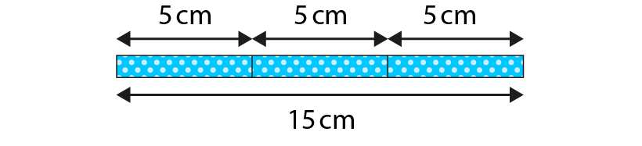  ‘The combined length of three spotty ribbons is fifteen centimetres.’  5 cm × 3 = 15 cm  ‘Five centimetres times by three is equal to fifteen centimetres.’  or  ‘Five centimetres multiplied by three is equal to fifteen centimetres.’  Concluding the length of the long ribbon:  ‘So the plain ribbon is fifteen centimetres long.’  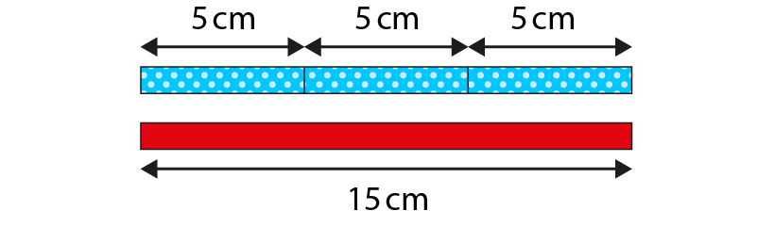  ‘The plain ribbon is three times the length of the spotty ribbon.’  5 cm × 3 = 15 cm  ‘The “5 cm” represents the length of one spotty ribbon.’  ‘The “3” represents the number of spotty ribbons that are equal to the length of the plain ribbon.’  ‘The “15 cm” represents the length of three spotty ribbons. It also represents the length of the plain ribbon.’
 | Now explore an example where one ribbon is ‘two times’ the length of the other, linking to the language of ‘twice’ and ‘double’ (segment 2.5 Commutativity (part 2), doubling and halving). Because children looked at halving in segment 2.5, they may also describe the relationship in these terms; however, fractional relationships are discussed explicitly in the next teaching point.  To focus more deeply on the idea of relative length, without measuring the shorter ribbon, ask children to identify possible equations that describe the relationship, as exemplified opposite and on the next page, and to discuss/reason about their answers. Then challenge them to write other possible equations that could match the same representation, with different lengths. Continue to include units in all equations, and to write the length (multiplicand) as the first factor and the scale factor (multiplier) as the second factor.  You could make similar comparisons using other ribbon lengths or Cuisenaire® rods. | Comparing the ribbons:  ‘The plain ribbon is shorter than the stripy ribbon.’  ‘The stripy ribbon is longer than the plain ribbon.’  Measuring the long ribbon in units of the short ribbon:  ‘The stripy ribbon is two times the length of the plain ribbon.’  ‘The stripy ribbon is twice the length of the plain ribbon.’  ‘The stripy ribbon is double the length of the plain ribbon.’  Identifying equations that could represent the relationship:  ‘Which equation(s) could describe the relationship between the lengths of the ribbons?’  5 cm × 2 = 10 cm  2 cm × 5 = 10 cm  10 cm = 2 × 5 cm  ‘Could this equation describe the relationship?’  4 cm × 2 = 8 cm
 | Now explore cases where the multiplier is one. First, remind children of the following generalisation (segment 2.4 Times tables: groups of 10 and of 5, and factors of 0 and 1): ‘When one is a factor, the product is equal to the other factor.’  Then compare two ribbons of the same length, as shown opposite. Explore what would happen if the known length was a different value and write the corresponding equation, working towards the following generalisation: ‘If two objects are the same length, one object is one times the length of the other.’ | Comparing the ribbons:  ‘The patterned ribbon is the same length as the plain ribbon.’  ‘The length of one plain ribbon is equal to the length of the patterned ribbon.’  ‘The patterned ribbon is one times the length of the plain ribbon.’  Writing an equation:  ‘If the plain ribbon is 8 cm long, how long is the patterned ribbon?’  8 cm × 1 = 8 cm  ‘Eight centimetres times/multiplied by one is equal to eight centimetres.’  ‘The patterned ribbon is eight centimetres long.’
 | Now, instead of comparing two separate lengths, consider how lengths can be compared when one object starts at a given length and then increases in length.  You could begin by giving children a piece of elastic and asking them to stretch it to twice/two times the length. Then work through a specific example, as a class, beginning with a piece of (slack) elastic that is 10 cm long, and then stretching it to twice the length. As a class, describe what is happening, and record the multiplication equation, as shown opposite. | ‘The elastic is ten centimetres long.’  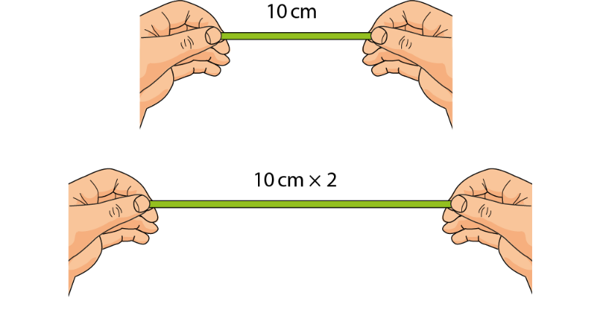  ‘We stretch it to two times the original length.’  10 cm × 2 = 20 cm  ‘Ten centimetres times/multiplied by two is equal to twenty centimetres.’  ‘The elastic is now twenty centimetres long.’

 | Work through some other contexts where the length of a given object is increased by an integer scale factor.  In the example opposite, the attribute being described is height; note that we say ‘ten times the original height’ and not ‘ten times taller’ so that the same phrasing can be used when the scale factor is fractional (Teaching point 2). You could also look at an example that describes width or depth, for example, ‘The water was three centimetres deep; now it is four times the original depth.’ | ‘I planted a twelve centimetre sunflower plant in the garden in April. By June it was ten times the original height. What was the height of the sunflower in June?’  12 cm × 10 = 120 cm  ‘Twelve centimetres times/multiplied by ten is equal to one hundred and twenty centimetres.’  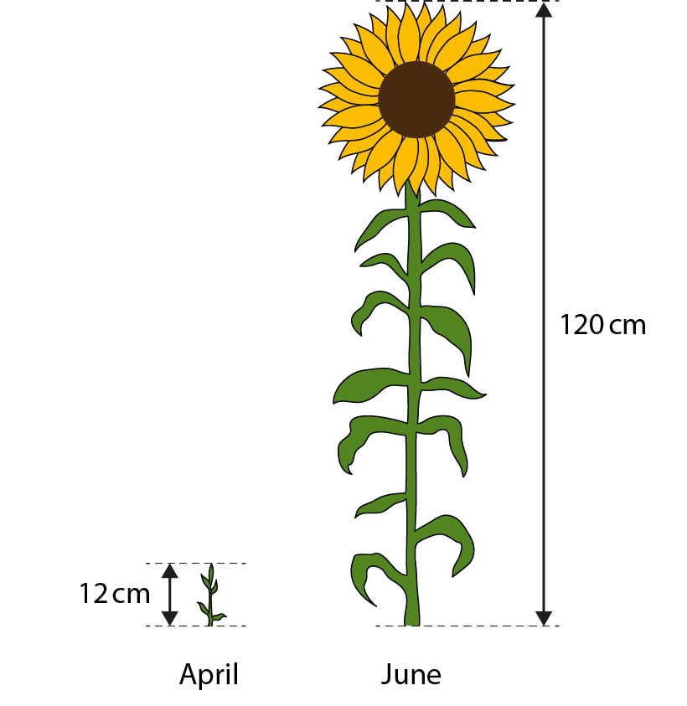  ‘In June, the sunflower is one hundred and twenty centimetres tall.’
 | Take a moment to briefly look at some equations in the absence of a context. As in segment 2.13 Calculation: multiplying and dividing by 10 or 100, use the following stem sentences:  ‘ multiplied by is equal to .’  ‘ is times the size of .’ | 7 × 3 = 21  ‘Seven times/multiplied by three is equal to twenty-one.’  ‘Twenty-one is three times the size of seven.’
To complete this teaching point, provide children with practice, including:
contexts in which one length is compared to another, as shown on the next page
contexts in which one length is increased; for example, ‘Twelve years ago, Marley planted a two-metre tall tree in her garden. The tree is now four times that height. How tall is the tree now?’
describing/writing abstract equations using comparative language.

Contextual problem – comparing two lengths:  ‘Charlotte is arranging the furniture in her room. Her wardrobe is three times the width of her cabinet. How wide is her wardrobe?’  Abstract problems:  ‘Fill in the missing numbers.’  9 × 8 = 72  72 is times the size of 9.  280 is 5 times the size of 56.  56 × = 280  6 × 8 =  is 8 times the size of 6. | Dòng nǎo jīn:  ‘Bo has a new pencil, but Tom and Alisha have sharpened their pencils a lot.’  ‘Complete this sentence.’  Bo’s pencil is times the length of Alisha’s pencil.  ‘Explain your reasoning.’

Teaching point 2:
A shorter length can be described in terms of a longer length using the language of fractions; the shorter length can be calculated, if the longer length is known, using division.

Steps in learning
 | Guidance | Representations
 | In this teaching point, children will use some of the same examples as in Teaching point 1, but now use their understanding of fractions to describe a shorter length in terms of a longer length. Throughout this teaching point, children will write multiplication equations with a fractional scale factor.  Begin by recapping the relationship between the spotty and plain ribbons used in step 1:1. Using the same examples as in the previous teaching point supports children in making connections between contexts where there is an increase in size/quantity (here, length) and a decrease in size/quantity. Children are more familiar with multiplication resulting in an increase, and need to appreciate it can also result in a decrease.  Recap the relationship between the plain ribbon and the spotty ribbon: ‘The plain ribbon is three times the length of the spotty ribbon.’  Then model how we can start the sentence with the spotty ribbon: ‘The spotty ribbon is one-third times the length of the plain ribbon.’  Write the corresponding multiplication equation.  Note that typically we would say ‘the spotty ribbon is one-third the length of the plain ribbon’; however, the word ‘times’ should be included, at this stage, to draw attention to the structure and link to the multiplication equation. | Review – describe and calculate the length of the long ribbon:  ‘The plain ribbon is three times the length of the spotty ribbon.’  5 cm × 3 = 15 cm  Describe the length of the short ribbon:  ‘The spotty ribbon is one-third times the length of the plain ribbon.’  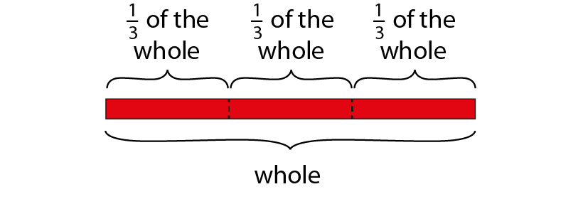  Writing the equation:  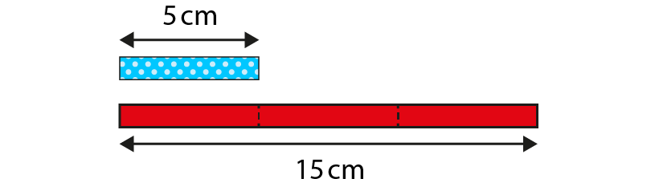
Link to children’s understanding of unit fractions using the language they already know:
‘The plain ribbon is the whole.’
‘If the whole is divided into three equal parts, each part is one-third of the whole.’
Emphasise that we are not actually cutting up the plain ribbon; we are comparing the length of the spotty ribbon to the plain ribbon.
 | In Spine 3: Fractions, segment 3.6, children learnt that multiplying a whole number by a unit fraction is the same as dividing that number by the denominator of the fraction. Use this connection to link the ribbon comparison to the corresponding division equation.  Repeat steps 2:1 and 2:2 with other lengths of ribbon. Here, and throughout the teaching point, use only whole-number lengths and unit-fraction scale factors. Include cases where the scale factor is one-tenth, linking back to what children learnt about strategies for dividing by ten in segment 2.13 Calculation: multiplying and dividing by 10 or 100. | 15 cm ÷ 3 = 5 cm
 | Now use the example from step 1:2, linking to children’s understanding of the connection between doubling and halving. As in steps 2:1 and 2:2:  first recap how we can describe and calculate the longer length in terms of the shorter length  then reverse the comparison using fractional language and a multiplication equation  then write the corresponding division equation. | Review – describe the length of the long ribbon:  ‘The stripy ribbon is two times the length of the plain ribbon.’  ‘The stripy ribbon is twice the length of the plain ribbon.’  ‘The stripy ribbon is double the length of the plain ribbon.’  Describe the length of the short ribbon:  ‘The plain ribbon is one-half times the length of the striped ribbon.’  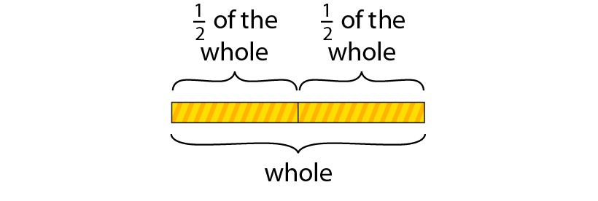  Identifying equations that could represent the relationship:  ‘Which equation(s) could describe the relationship between the lengths of the ribbons?’  10 cm ÷ 2 = 5 cm  10 cm ÷ 5 = 2 cm  ‘Could these equations describe the relationship?’  8 cm ÷ 2 = 4 cm

 | Now consider how lengths can be compared when the one object starts at a given length and then decreases in length. | ‘A pencil was twenty centimetres long when it was new. It is now one-quarter times its original size. How long is the pencil now?’  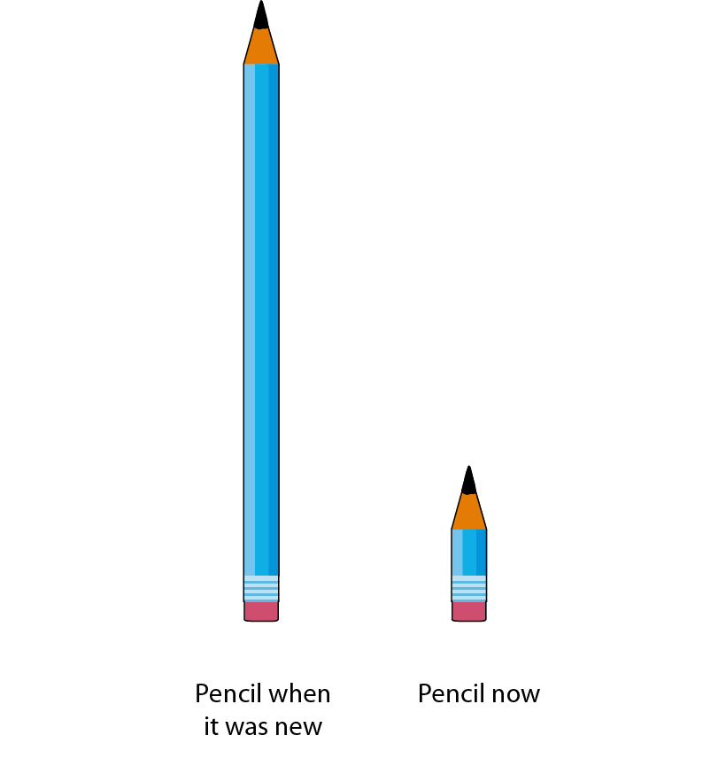  20 cm ÷ 4 = 5 cm  ‘The pencil is now five centimetres long.’
 | As in step 1:6, briefly look at some equations, in the absence of context. Use the following stem sentences:  ‘ multiplied by is equal to .’  ‘ divided by is equal to .’  ‘ is times the size of .’ | 21 ÷ 3 = 7 cm  ‘Twenty-one times/multiplied by one-third is equal to seven.’  ‘Twenty-one divided by three is equal to seven.’  ‘Seven is one-third times the size of twenty-one.’
 | To complete this teaching point, provide children with practice similar to that described in step 1:7, but now for unit-fraction scale factors. Also include problems that involve looking at the relationship described ‘both ways’, as exemplified on the next page with the garage and house.

 | Contextual problem – comparing two heights: ‘Which sentences could describe the picture?’ True () or false () The house is double the height of the garage. The garage is double the height of the house. The house is one-half times the height of the garage. The house is two times the height of the garage. The garage is times the height of the house. ‘Which equations could represent this picture? For each equation that could represent the picture, describe what each number represents.’ Abstract problems: ‘Fill in the missing numbers.’ 72 ÷ 8 = 9 9 is times the size of 72. 56 is one-fifth times the size of 280. 280 × = 56 280 ÷ = 5 48 × = 6 48 ÷ = 6 6 is times the size of 48. Dòng nǎo jīn: ‘Snail B travels down the garden path.’ ‘Snail A travels one-quarter the distance of Snail B.’ ‘Snail C travels three times the distance of Snail A.’ ‘Who travels further: Snail B or Snail C?’

Teaching point 3:
Other measures can be compared using the language of ‘times’ and fractions, and calculated using multiplication or division.

Steps in learning
 | Guidance | Representations
 | Once children are able to describe relationships between shorter and longer lengths, and use multiplication or division to calculate one length, given another and the relationship between them, extend to comparison and calculation in other measures contexts, such as mass, capacity/  volume and money. Note that we cannot compare temperature in this way, because 0° does not mean there is ‘no temperature’ in the same way that 0 cm means there is ‘no length’ of something; the temperature scale cannot be understood in the same way as other measures. Also, when considering time as a measure, it is possible to compare durations using multiplicative reasoning, but not instances of time.  Begin with an example involving mass, such as that shown opposite. Bring together learning from both Teaching points 1 and 2, to describe the larger mass in terms of the smaller mass, and to calculate the larger mass given the smaller mass, and vice versa.  Adapt the stem sentence from Teaching points 1 and 2: ‘The is times the mass of the .’  Then reverse the problem, ensuring that children can describe/calculate the smaller mass in terms of the larger mass. | Describing and calculating the larger mass in terms of the smaller mass:  ‘The mass of a mother bear is four times the mass of her cub. The mass of the cub is 25 kg. What is the mass of the mother bear?’  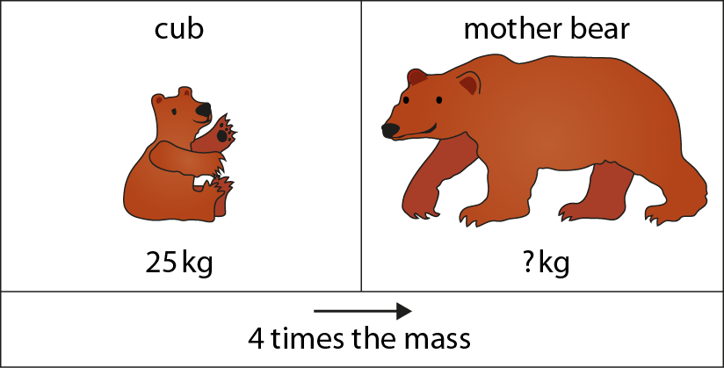  ‘The mass of the mother bear is four times the mass of her cub.’  25 kg × 4 = 100 kg  ‘The mass of the mother bear is one hundred kilograms.’

Describing and calculating the smaller mass in terms of the larger mass:
‘The mass of a bear cub is one-quarter times the mass of his mother. The mass of the mother cub is 100 kg. What is the mass of the cub?’
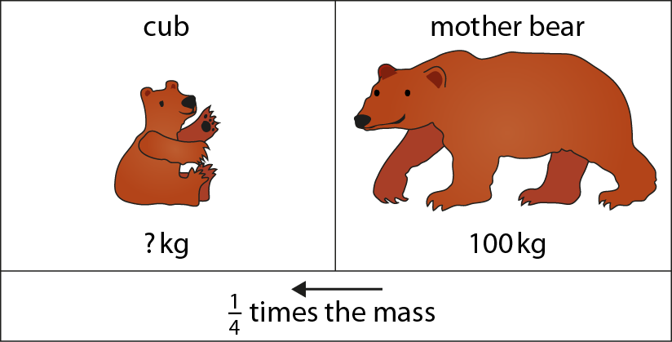
‘The mass of the bear cub is one-quarter times the mass of his mother.’
100 kg ÷ 4 = 25 kg
‘The mass of the bear cub is twenty-five kilograms.’
 | Work through a variety of measures contexts. As in Teaching points 1 and 2, include:  comparing one measure to another  comparing a single measure at given points in time (for example, ‘An iceberg had a mass of 1000 kg; now the iceberg is one-fifth times the original mass.’)  examples where the scale factor is equal to ‘1’ or ‘0’.  You could work practically to compare:  capacities of different containers (for example, we have to use a 250 ml container four times to fill up a 1000 ml / 1 litre container; we can pour one-quarter of the water out of a 1000 ml / 1 litre container into a 250 ml container)  masses using measuring scales  durations by counting (or using a stop watch) to see how long it takes to do different tasks.  As before, keep to whole-number measures.  As shown opposite you can start to omit the word ‘times’ when using fractional language. | Example 1 – capacity:  ‘What is the relationship between the volume of orange juice and the volume of cranberry juice?’  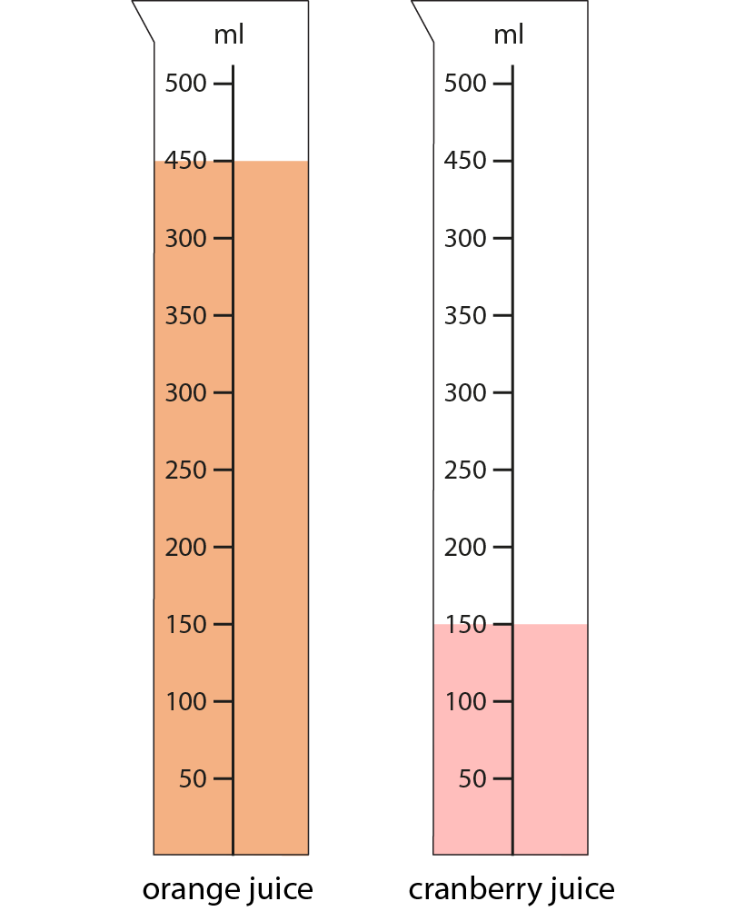  ‘The volume of orange juice is three times the volume of cranberry juice.’  150 ml × 3 = 450 ml  ‘The volume of cranberry juice is one-third the volume of orange juice.’  450 ml ÷ 3 = 150 ml

Example 2 – mass/weight:
‘The weight of the sugar is two times/twice/double the weight of the butter. How much does the sugar weigh?’
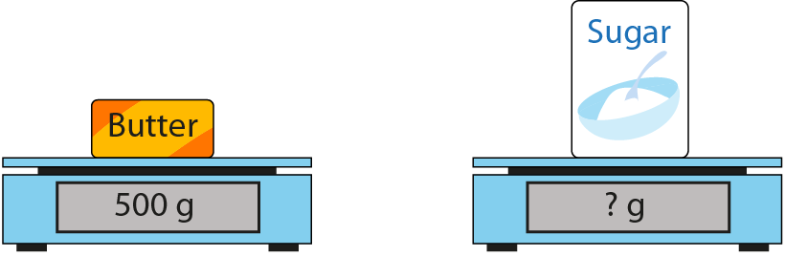
 | Provide children with practice similar to that described in steps 1:7 and 2:6, but now using a variety of different measures contexts. | Contextual example:  ‘It takes Paul ninety seconds to run one hundred metres. His older brother can run one hundred metres in  one-third of Paul’s time. Which equations could represent this situation?  Dòng nǎo jīn:  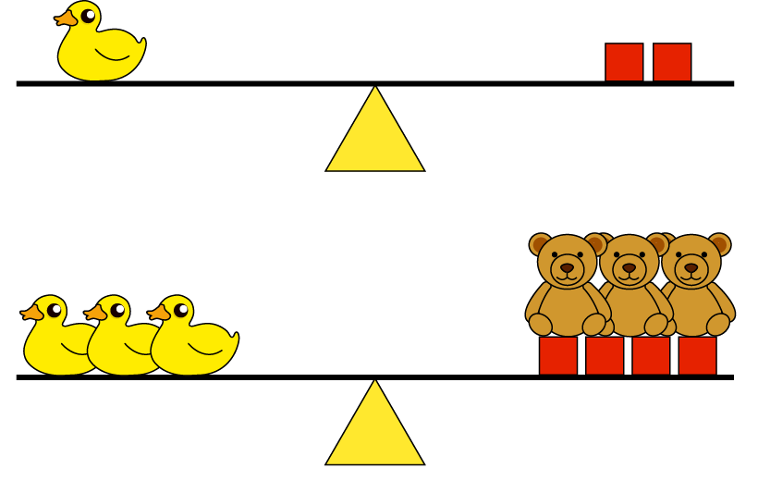  ‘Look at the picture and complete these sentences.’  A duck is times as heavy as a brick.  A duck is times as heavy as a bear.  bears weigh the same as 2 bricks.

